Core Java OOPS -Lab

Class and Object

1. 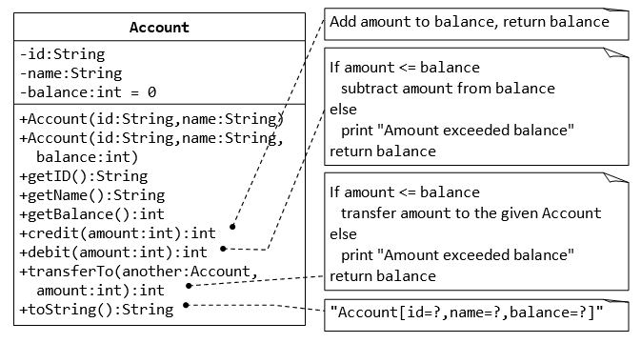

#### 2. Composition- Author and Book Classes

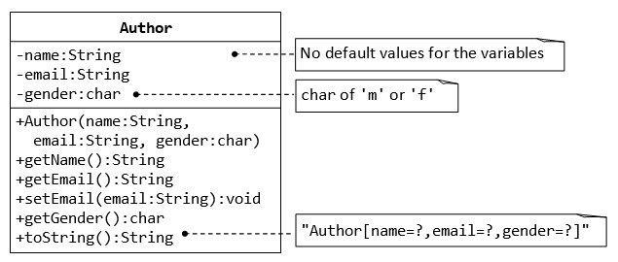

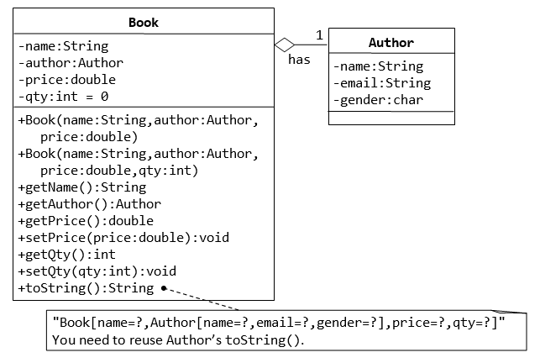

**3. The Customer and Account Class**

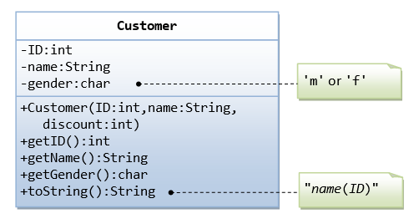

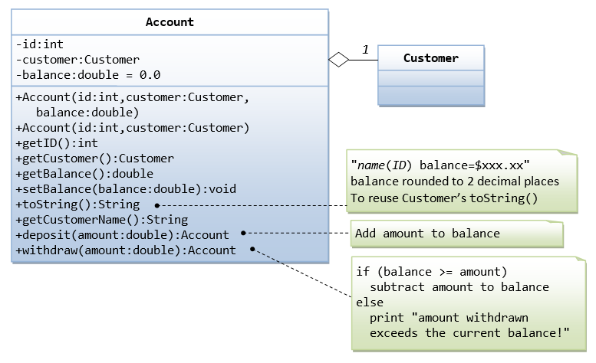

The Account class models a bank account, design as shown in the class diagram, composes a Customer instance (written earlier) as its member. Write the codes for the Account class and a test driver to test all the public methods.

4. inheritance

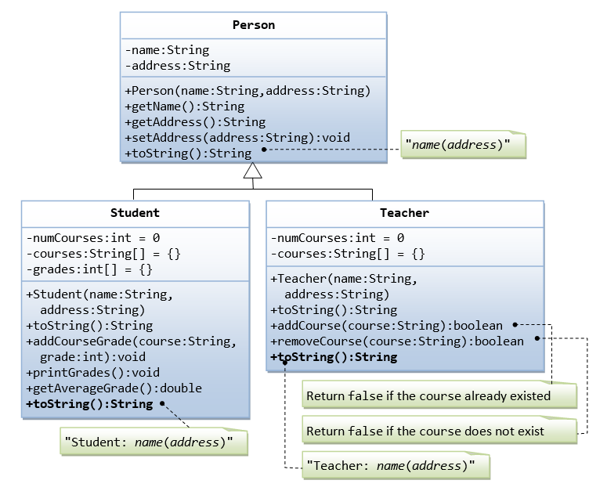

Suppose that we are required to model students and teachers in our application. We can define a superclass called Person to store common properties such as name and address, and subclasses Student and Teacher for their specific properties. For students, we need to maintain the courses taken and their respective grades; add a course with grade, print all courses taken and the average grade. Assume that a student takes no more than 30 courses for the entire program. For teachers, we need to maintain the courses taught currently, and able to add or remove a course taught. Assume that a teacher teaches not more than 5 courses concurrently.

5.

